**All About Mrs. Mandala**

*Welcome to first grade! I grew up in Greensboro and have been here my whole life. I have two sons named Devon and PJ. I have been married for 14 years to my husband Pete. I love teaching and I love being a Lindley Lion! I am looking so forward to meeting my new first graders! Although we are starting school off virtually and not face to face, I know your kids will do a great job! My goal is to support you and your children and make this journey as smooth as possible. Please don’t hesitate to reach out to me for any needs!*

*I*

**My Hobbies**

I love spending time with my family, working out, and reading. Recently I started taking piano lessons too!

**My College**

I graduated college from

**UNCG**

**Go Spartans!**



**Where I’ve Taught**

This will be my 13th year teaching! I taught third grade at Gibsonville Elementary and fifth grade at Irving Park Elementary. At Lindley, I’ve taught fourth grade and first grade. This will be my second year teaching first!



**My Favorites**

**Color: Purple**

**Food: Tacos**

**Drink: Coffee**

**Season: Summer**

**Sport: Swimming**

**My Fur Baby**

This is my sweet border collie Breezy. She is almost 16 years old!

**My Family**

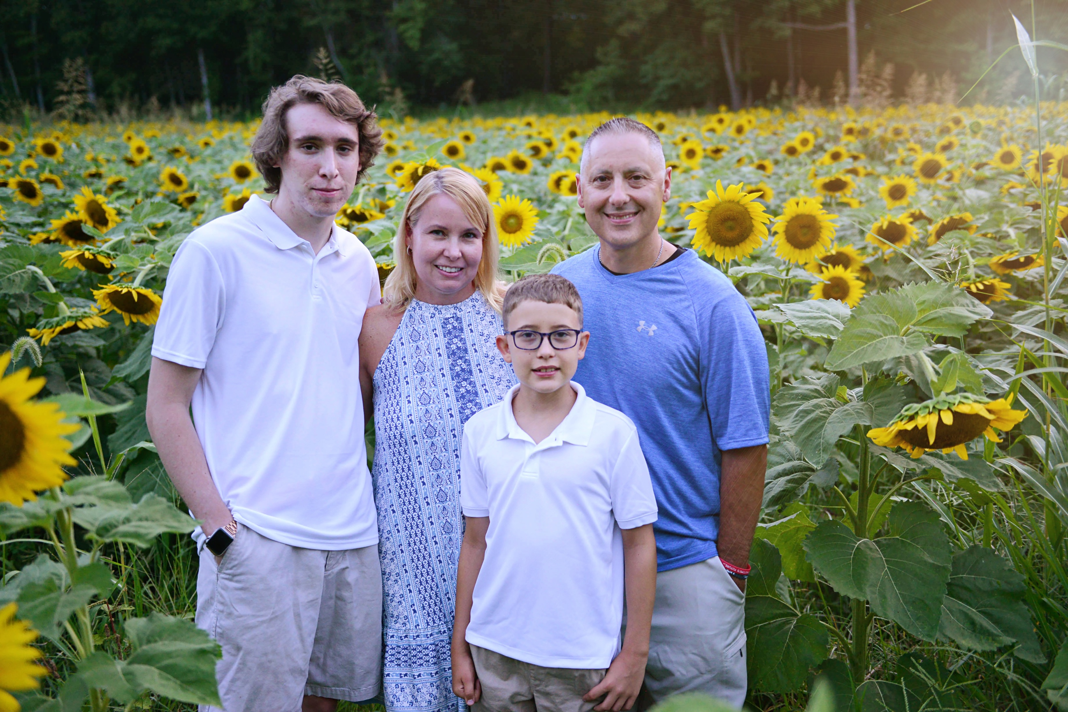



**My Professional Goals**

My goal is to make learning fun and exciting! I want to connect with each of my students and help to foster a love of learning!

**My Sports Team**



**My Contact Info**

Jill Mandala

mandalj@gcsnc.com

336-601-5542